

**Auction**



Informatics Project

Report

By:

Name:-Sai Hitesh Putta

Roll no:-

Class:-XII MAE Informatics





**Dedicated At His**

**Lotus Feet**

Table of Contents

**Acknowledgement4**

**AIM5**

**INTRODUCTION6**

**WHY IS IT NECESSARY?7**

**HOW DOES IT WORK?8**

**SCOPE OF PROJECT9**

**SOFTWARES AND LIBRARIES………………………………………..10**

**PROGRAM DESIGN……………………………………………………..11**

**DATABASE STRUCTURE………………………………………………12**

**PROGRAM CODE………………………………………………………..13**

**SCREENSHOTS…………………………………………………………**

**FUTURE ENHANCEMENTS…………………………………………**

**REFERENCES…………………………………………………………..**

Acknowledgement

No Art is ever complete without the Master artist’s touches. And to the Master of Masters **BHAGAWAN SRI SATHYA SAI BABA**, I offer my deep sense of gratitude. The wonderful faculty in the school that are handpicked by HIM have been or pillars of support throughout this journey.

I would love to utilize this opportunity to offer my gratitude to the principal, **SHRI SIVARAMAKRISHNAIAH** for presenting me this wonderful opportunity which was filled with fun and learning at the same time.

A special vote of thanks is due to my Informatics teacher, **SHRI SAI PAVAN** for guiding me all along this wonderful saga of exploration and deep dive into this subject.

No journey can be smooth throughout and during the rough phases one needs to shoulder to rely on. And to those shoulders of my **family** and my **classmates**, I offer my deepest of thanks.

Aim

To create a basic Auction Software using socket programming

from Python

Introduction

An auction that can be held across different computers in a same network

is something that can never be dreamt of because no one would have got

that idea. This software is designed and coded for that purpose of bidding

in an auction right in your homes in your computer.

With just a click you can bid for anything , you can be someone who is

auctioning something or you can be taking part in some auction started by someone.

You can add a new item you want to auction along with the description to it.

Everything has an end so is the item which is getting auctioned if its not auctioned

in a particular time then you will lose the opportunity of acquiring it.

WHy is it necessary?

It provides the necessary tools for sellers to list items, buyers to bid

on them, and administrators to monitor them. The software **helps**

**automate the bidding process**, allowing buyers to bid from

any location at a given time without having to be physically present

at the auction

How does it work?

Firstly if you want to auction a product you need to add that

item to the products using an ADD ITEM feature available in the software,

Next you need to go to the auction page in the software search up the item you would like to auction and click on the start auction button in that page and the starts the server and waits for clients to join after the waiting is done once the minimum number of clients is reached then the auction starts and then you can happily enjoy bidding.

scope of the project

This software is designed to reduce the pressure of people taking part in an auction to

go to a particular place then bid for the item they can do it at ease sitting in their own

houses. Our software enables you to have an auction amongst any number of people

at once. It is efficient enough to give everyone a smooth experience you can save a

lot of time and money using this software.

Softwares & Libraries

* **PyCharm Community Edition 2023.3.3**

PyCharm is an integrated development surroundings (IDE) used for programming in Python. It is advanced by means of the Czech organization JetBrains and is to be had for Windows, mac OS, and Linux. PyCharm is to be had in two variations: Community Edition and Professional Edition. The Community Edition is loose and open supply, while the Professional Edition is a paid subscription carrier.

* **Python 3.12**

Python is a set of instructions that we give in the form of a Program to our computer to perform any specific task. It is a Programming language having properties like it is interpreted, object-oriented and it is high-level too. Due to its beginner-friendly syntax, it became a clear choice for beginners to start their programming journey. The major focus behind creating it is **making it easier for developers to read and understand, also reducing the lines of code.**

* **PyQt5**

PyQt5 is a set of Python bindings for the Qt application framework, allowing Python to be used for cross-platform desktop and mobile application development. It provides tools to create user interfaces that can run on various operating systems, including Windows, mac OS, Linux, iOS, and Android.

* **Sys**

The **sys module**in [Python](https://www.geeksforgeeks.org/python-programming-language/) provides various functions and variables that are used to manipulate different parts of the Python runtime environment. It allows operating on the interpreter as it provides access to the variables and functions that interact strongly with the interpreter.

* **QtDesigner**

[**Qt Designer** is a **tool for designing and building graphical user interfaces (GUIs) with Qt Widgets**](https://www.bing.com/ck/a?!&&p=30f7f961d728b012JmltdHM9MTcyODY5MTIwMCZpZ3VpZD0wZjcwMTZkNi0xZTU2LTZmMDMtM2FmMC0wMjgzMWYzZjZlZDkmaW5zaWQ9NTc5Nw&ptn=3&ver=2&hsh=3&fclid=0f7016d6-1e56-6f03-3af0-02831f3f6ed9&psq=what%27s+qt+Designer&u=a1aHR0cHM6Ly9kb2MucXQuaW8vcXQtNi9xdGRlc2lnbmVyLW1hbnVhbC5odG1s&ntb=1). [It provides a **what-you-see-is-what-you-get (WYSIWYG) interface** to create GUIs for PyQt applications by dragging and dropping QWidget objects on an empty form](https://www.bing.com/ck/a?!&&p=284df4516d4aa2dfJmltdHM9MTcyODY5MTIwMCZpZ3VpZD0wZjcwMTZkNi0xZTU2LTZmMDMtM2FmMC0wMjgzMWYzZjZlZDkmaW5zaWQ9NTgwMA&ptn=3&ver=2&hsh=3&fclid=0f7016d6-1e56-6f03-3af0-02831f3f6ed9&psq=what%27s+qt+Designer&u=a1aHR0cHM6Ly9yZWFscHl0aG9uLmNvbS9xdC1kZXNpZ25lci1weXRob24v&ntb=1).

* **MySQL**

**MySQL**is a popular open-source **Relational Database Management System** (RDBMS) that uses **SQL**(Structured Query Language) for database operations. While MySQL is a specific database system accessible for free and supports various programming languages.

* **Sockets**

Socket programming is a way of connecting two nodes on a network to communicate with each other. One socket (node) listens on a particular port at an IP, while the other socket reaches out to the other to form a connection. The server forms the listener socket while the client reaches out to the server. They are the real backbones behind web browsing. In simpler terms, there is a server and a client.

* **Threading**

A **thread**is an entity within a process that can be scheduled for execution. Also, it is the smallest unit of processing that can be performed in an OS (Operating System). In simple words, a thread is a sequence of such instructions within a program that can be executed independently of other code.

* **Traceback**

**Traceback** is a python module that provides a standard interface to extract, format and print stack traces of a python program. When it prints the stack trace it exactly mimics the behaviour of a python interpreter. Useful when you want to print the stack trace at any step. They are usually seen when an exception occurs.

* **Subprocess**

The subprocess module present in Python is used to run new applications or programs through Python code by creating new processes. It also helps to obtain the input/output/error pipes as well as the exit codes of various commands.

program design

* **Login Page**

The Login Page is the entry point for users, where they enter their credentials—username and password. The system checks these against stored data in a secure database. Successful authentication grants access to the software, ensuring that only authorized individuals can enter and use the platform.

* **Auction Page**

The Auction Page allows users to start and manage auctions. Here, users can initiate an auction event and engage with all registered clients. This page typically features options to set the auction parameters, such as starting time, duration, and rules, facilitating seamless interaction and participation.

* **Products Page**

The Products Page showcases all items available for auction. It provides users with detailed information, including descriptions, images, and starting bid prices. This comprehensive view helps users make informed decisions when placing bids, as they can easily compare products and assess their value.

* **Add Item Page**

The Add Item Page enables users to submit new items for auction. Users can fill out necessary details, such as the item’s name, description, starting bid, and images. This feature encourages participation by allowing users to contribute items, thereby diversifying the auction inventory and enhancing the auction experience for everyone.

* **Bids Page**

The Bids Page displays all items that users have successfully purchased in previous auctions. It includes information about each transaction, such as item names, final prices, and auction dates. This functionality helps users keep track of their purchases and manage their auction activities efficiently.

* **Profile Page**

The Profile Page allows users to manage their personal information and preferences. Users can edit their profiles, update contact details, and adjust settings related to their auction activities. Additionally, this page enables other users to view profile information, fostering a sense of community and trust within the auction environment.

Database structure

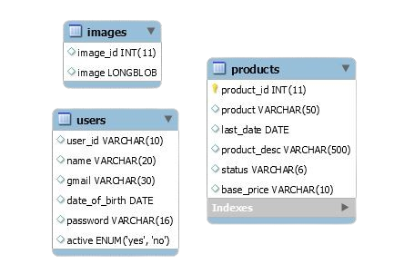

Database

* **Users**

+---------------+------------------+------+-----+---------+-------+

| Field | Type | Null | Key | Default | Extra |

+---------------+------------------+------+-----+---------+-------+

| user_id | varchar(10) | YES | | NULL | |

| name | varchar(20) | YES | | NULL | |

| gmail | varchar(30) | YES | | NULL | |

| date_of_birth | date | YES | | NULL | |

| password | varchar(16) | YES | | NULL | |

| active | enum('yes','no') | YES | | no | |

+---------------+------------------+------+-----+---------+-------+

* **Products**

+--------------+--------------+------+-----+---------+-------+

| Field | Type | Null | Key | Default | Extra |

+--------------+--------------+------+-----+---------+-------+

| product_id | int(11) | NO | PRI | NULL | |

| product | varchar(50) | YES | | NULL | |

| last_date | date | YES | | NULL | |

| product_desc | varchar(500) | YES | | NULL | |

| status | varchar(6) | YES | | unsold | |

| base_price | varchar(10) | YES | | NULL | |

+--------------+--------------+------+-----+---------+-------+

* **Images**

+----------+----------+------+-----+---------+-------+

| Field | Type | Null | Key | Default | Extra |

+----------+----------+------+-----+---------+-------+

| image_id | int(11) | YES | | NULL | |

| image | longblob | YES | | NULL | |

+----------+----------+------+-----+---------+-------+

Screenshots

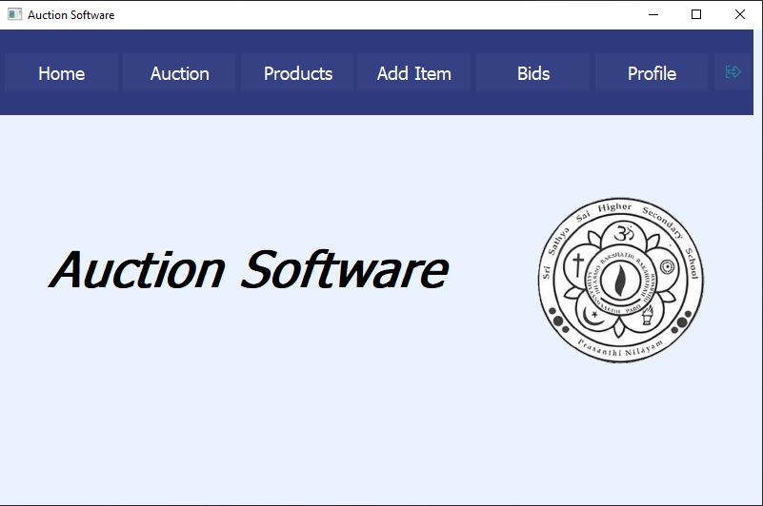

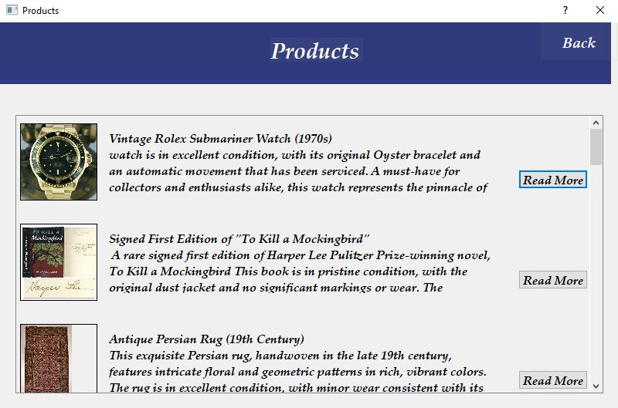

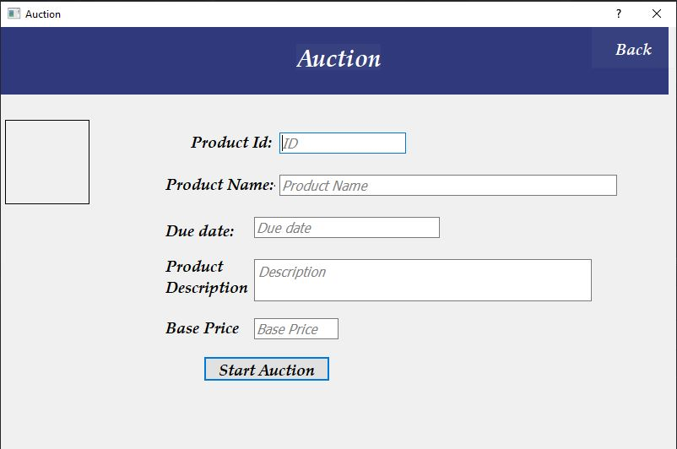

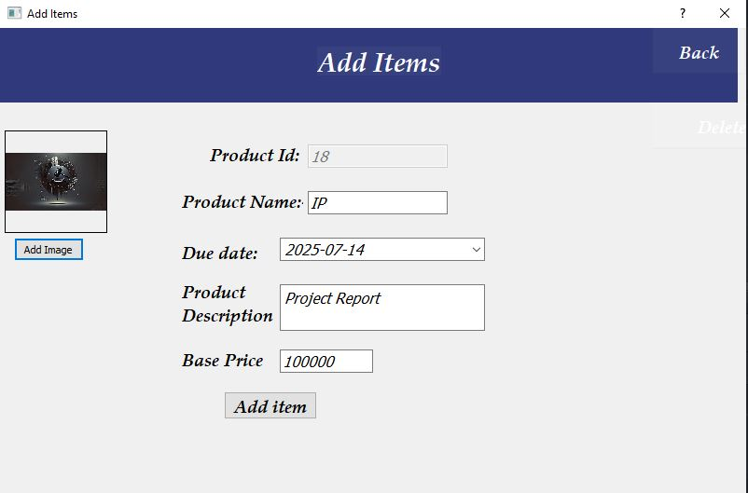

future enhancements

* Enable the platform to host multiple auctions at the same time, allowing users to participate in various auctions simultaneously.
* Introduce different user roles (e.g., admin, bidder, seller) with specific permissions to manage access and functionalities effectively.
* Support various auction formats such as Dutch, sealed-bid, and reverse auctions, catering to diverse user needs and preferences.
* Implement real-time notifications for bid changes, ensuring users receive instant updates without needing to refresh the page.
* Allow users to set a maximum bid amount that automatically raises their bid if they are outbid, streamlining the bidding process.
* Develop a mobile application to provide users with easy access to auctions and bidding from their smartphones.
* Integrate multiple payment gateways (e.g., credit cards, PayPal) for seamless transactions during and after auctions.
* Provide access to detailed auction histories, including past bids and winners, allowing users to analyze trends and make informed decisions.
* Enable users to rate and review sellers post-auction to build trust and assist future bidders in making informed choices.
* Introduce a verification process for high-value items to confirm authenticity, enhancing buyer confidence.

References

* CBSE Informatics Practices Textbook
* [www.geeksforgeeks.com](http://www.geeksforgeeks.com)
* [www.stackoverflow.com](http://www.stackoverflow.com)
* [www.w3schools.com](http://www.w3schools.com)
* www.github.com